Inside this issue:

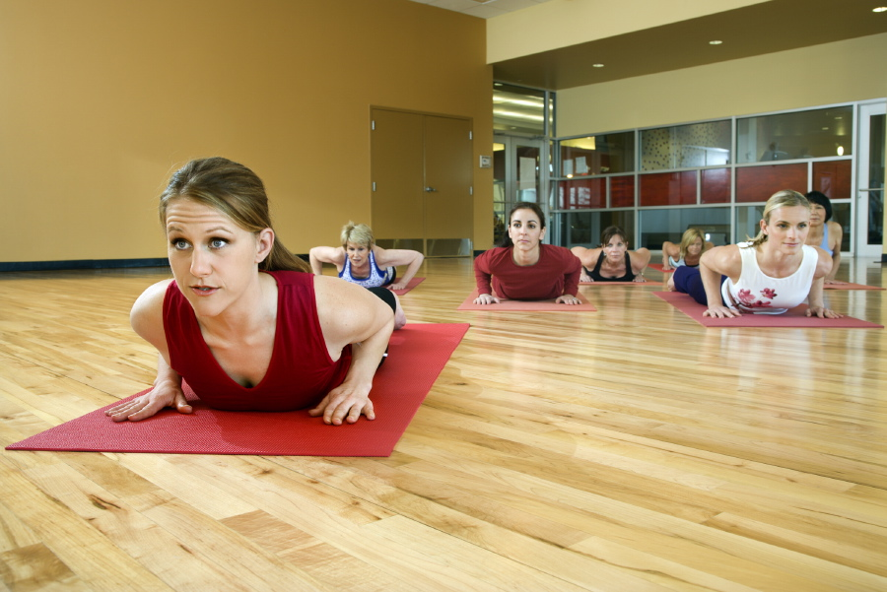

Planet FitnessC:\Users\skriek8100\AppData\Local\Microsoft\Windows\Temporary Internet Files\Content.IE5\RWY0TVT5\MM900286723[1].gif

|  |  |
| --- | --- |
| Afterschool Movement | 1 |
| Dress code requirement | 1 |
| Field Trips | 2 |
| Sports Teams | 2 |
| Fitness calendar | 2 |
| Class rules and test taking skills | 2 |
| Coach’s corner | 2 |

The proper clothing requirements for physical education this school year will be a white t-shirt and athletic gym shorts. The white t-shirts must be tucked in at all times. The gym shorts must be size to fit and not be saggy or sloppy fit. All students must wear tennis shoes. No sandals or high heels are allowed to be worn during P.E. No t-shirts with smoking or sexual content are allowed to be worn during P.E class. No cellphones are allowed to be used during P.E class. The dress code will remain the same through-out the school year. In the winter the students will have P.E classes inside the gym. If a student fails to dress out for 3 classes this results in an F.

### Coach N. Mallard, inst.

## Physically Fitness Attire! What to wear?

Important Points:

* Only a doctor’s excuse or parental conference will be accepted for excused absences.
* No cell phones allowed!!
* No open toe shoes.
* No explicit content t-shirts.

Physically Fun!!!!!!!!

# “Turn Up” for Movement!!!

The purpose of this section of the newsletter is to get children at an early age to become more active (physically) instead of sitting inside doing nothing.

In September, the Director of the Athletics is offering a one hour afterschool musical movement class to children who may be interested in attending. The class will teach the children the art of yoga, dance moves, and a series of fun games that are centered on the goal of being physically active. The times for the class will be from five o clock until six o clock in the evenings from Monday through Thursday. Parents of the children are also welcome to sign up for the class as well, but an ID must be shown at the door to identify you as the child’s legal guardian.

The musical movement class will be held in the School’s gym. Before the first class begins, an orientation will be held on Saturday at four p.m. in the gymnasium. This will help everyone attending the class, children and parents, to get a chance to mingle with one another.

Refreshments will be available to everyone in attendance at the orientation.

If you have any more questions about the class please contact us at (229) 435-9086 or fax (229)-435-7221.

October 2013

Volume 1, Issue 1

Week 1 & 2

Preparation and Physical Fitness Tests

Week 3 & 4

Music and Movement

Week 5

Throwing and Catching

“A Winner Never Quits, and a Quitter Never Wins”

lace an interesting sentence or quote from the story here.”

## Field trips

C:\Program Files\Microsoft Office\MEDIA\CAGCAT10\j0183328.wmf

## School Organized Team Sports!

This school year we are offering the students a chance to participate in a variety of team oriented sports. This is a chance for the students to learn how to apply fundamentals to their respected sport that they may chose. All students who are interested in playing on an organized sports team will need to complete three evaluations before playing. First a physical checkup form must be completed and turned in to the Director of Athletics, second the student will need to present a healthcare insurance card, and third, a concussion medical form must be completed by the parents of the students. The sports that will be available for the students to play will be football, basketball, baseball, softball, volleyball, and soccer. Our goal is to teach the students about teamwork and how to mentally translate plays from a playbook into a game setting. We want to provide a great experience not just for the students who are participating in the sports but for everyone in the community as well. A meeting will be held in the lunchroom on August 6 to discuss funding for the sports teams uniforms. Please contact us at (229)435-9085 for more information.



## Physical Education Calendar

| October | | | | | | |
| --- | --- | --- | --- | --- | --- | --- |
| M | T | W | T | F | S | S |
|  | 1 | 2 | 3 | 4 | 5 | 6 |
| 7 | 8 | 9 | 10 | 11 | 12 | 13 |
| 14 | 15 | 16 | 17 | 18 | 19 | 20 |
| 21 | 22 | 23 | 24 | 25 | 26 | 27 |
| 28 | 29 | 30 | 31 |  |  |  |

During the school year we are trying to schedule one field trip each month for the best behaved P.E classes in each grading period. We are currently working on a possible fieldtrip to Six Flags on a Friday afternoon, and for an end of the year trip, we plan to take the best behaved class to an Atlanta Hawks basketball game. We feel that the students who follow directions and work hard at trying to get better while performing their daily P.E instructions of the day should be rewarded. The field trip dates for these events will be announced at a later date. If you have any questions about the field trip plans in general please contact us at (229)435-9085.

C:\Users\skriek8100\AppData\Local\Microsoft\Windows\Temporary Internet Files\Content.IE5\RWY0TVT5\MC900060306[1].wmf

State Physical Fitness Test in October!!

## Class Projects for Physical Education

Two class projects will be completed for the school year in Physical education. Both projects will be centered on motor movement. The class projects will be completed by students individually or by a group.

The first project will focus on Aerobics and Dance while the second project will focus on a videotaped self-assessment of a sports skill that the student has learned from the class. The Aerobics and Dance project require for students to work in groups or individually to create an original dance or an aerobic routine. A CD and Tape Player can be used to help the students in designing their own styles. The goal for the self-assessment project is to show the students how important fundamentals are when a person is performing a sports skill. A camcorder can be used as a resource to help the students with the self-assessment project. The key to both projects is to show the students that everything from dancing to a favorite and throwing a football requires some kind of motor movement.

C:\Users\skriek8100\AppData\Local\Microsoft\Windows\Temporary Internet Files\Content.IE5\3FVSBHWL\MC900235179[1].wmf

* Make sure you get a good night’s rest before starting your test.
* Be sure to involve exercise in your daily routine to be physically alert and fit.
* Eat a nutritious breakfast before testing.
* Stay focused on the task at hand.
* Make sure that you read and reread all directions( if time permits).
* Do your very best!



## Test -Taking Tips from the Gymnasium!!!!!!!!

When a class comes into the gym they must follow each rule that the P.E teacher has stated in his or her instructions. If these rules are broken than the child will be sent to the office.

These are the rules of the gym.

* No Fighting
* No Bullying
* No Cursing
* No Cheating

The students will have weekly expectations placed on them regarding the skills that they are performing each week. For example, the dribbling of a basketball while walking may progress to running before the week is over. Next Monday that student must at least know how to dribble a basketball while walking. Each week I will teach a skill and monitor each child’s progress. There will be a review of the previous skill on the start of the next week and every child should be able to complete that skill set with a 100% success rate.

C:\Users\skriek8100\AppData\Local\Microsoft\Windows\Temporary Internet Files\Content.IE5\AZXAMO5U\MC900060327[1].wmf

phone

## Class Rules and Expectations



## Coach’s Corner

My name is Mr. Nicholas K. Mallard, and I am presently serving as your physical education instructor and head football coach. I believe in making sure that all children receive quality physical education instructions on a daily basis. I invite all parents to become actively involved in your children’s’ physical fitness.

I desire to meet the parents of all of my students this school year. I need and appreciate all of your support as I work with your children to improve their physical fitness.

Coach Nicholas K. Mallard,

Physical Education Instructor

H. Simpson Middle School

2237 Mallard Way

Springfield, Mass. 20204

E-mail address: coachmallard@hsimpsonms.com

Web site address: www.warhawks.org

logo